1. **The same treatment was used in both the prophet’s time and modern time, but the technology is evolved in the modern time. This treatment has evolved nowadays and has been used in various formats such as: Electric Cauterization**

PREFIX rdfs: <[http://www.w3.org/2000/01/rdf-schema#](http://www.w3.org/2000/01/rdf-schema)>

PREFIX owl: <[http://www.w3.org/2002/07/owl#](http://www.w3.org/2002/07/owl)>

PREFIX rdf: <[http://www.w3.org/1999/02/22-rdf-syntax-ns#](http://www.w3.org/1999/02/22-rdf-syntax-ns)>

PREFIX uni: <[http://www.semanticweb.org/muna/ontologies/2018/6/TibbNabawi-ontology-15#](http://www.semanticweb.org/muna/ontologies/2018/6/TibbNabawi-ontology-15)>

SELECT distinct ?medical_condition ?annotation ?Prophet_treatment ?hadeeth ?Modern_Treatment

WHERE {

?medical_condition rdfs:subClassOf ?x.

?x owl:onProperty uni:hasBeenTreated.

?Prophet_treatment rdfs:subClassOf uni:Prophet_timeTreatment.

?modern_treatment rdfs:subClassOf uni:ModernMedicalTreatments.

?Modern_Treatment rdfs:subClassOf ?modern_treatment.

?x ?y ?Prophet_treatment .

?x ?y ?modern_treatment .

FILTER ( ?Prophet_treatment = ?modern_treatment)

optional {

?medical_condition rdfs:isDefinedBy ?annotation.

?modern_treatment rdfs:subClassOf ?s.

?s owl:onProperty uni:isStronglyVerifiedBy.

?ind rdf:type uni:Authentic_Hadith.

?ind uni:desrcirption_of_Hadeeth ?hadeeth.

?s ?t ?ind.

}

}

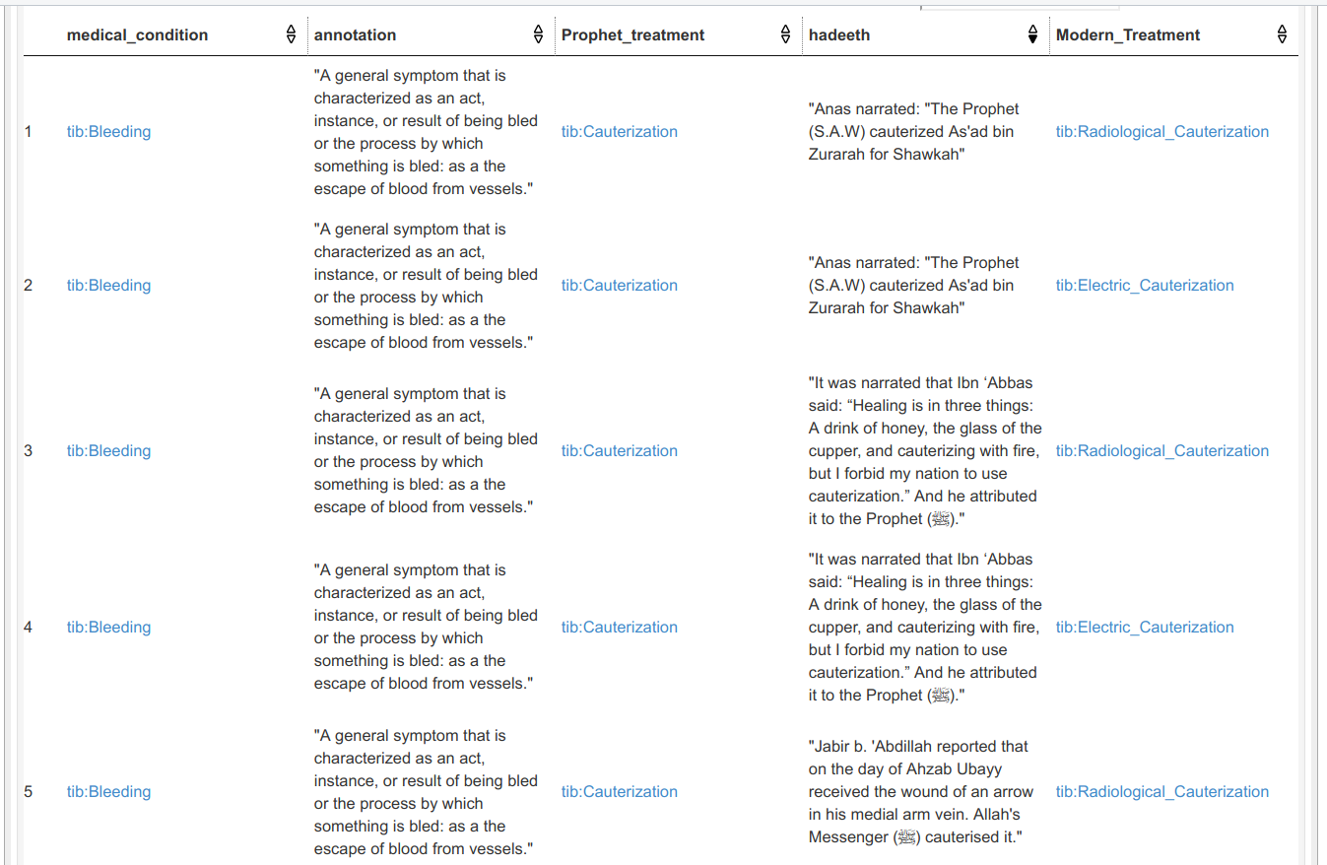

**2- The treatment was recommended by the prophet in his time, but modern technology is advanced and modern research proved its powerful effectiveness.**

**An Example is the recommendation of the prophet (s.a.w) about Miswak**

**Query:**

PREFIX rdfs: <[http://www.w3.org/2000/01/rdf-schema#](http://www.w3.org/2000/01/rdf-schema)>

PREFIX owl: <[http://www.w3.org/2002/07/owl#](http://www.w3.org/2002/07/owl)>

PREFIX rdf: <[http://www.w3.org/1999/02/22-rdf-syntax-ns#](http://www.w3.org/1999/02/22-rdf-syntax-ns)>

PREFIX uni: <[http://www.semanticweb.org/muna/ontologies/2018/6/TibbNabawi-ontology-15#](http://www.semanticweb.org/muna/ontologies/2018/6/TibbNabawi-ontology-15)>

select ?medical_prevention ?prophet_material ?Modern_biomedical_research ?biomedical_research_reference ?hadeeth

where{

?prophet_material rdfs:subClassOf ?x.

?x owl:onProperty uni:treat.

?medical_prevention rdfs:subClassOf uni:medical_prevention.

?x ?y ?medical_prevention .

?medical_prevention rdfs:subClassOf ?i.

?i owl:onProperty uni:hasBeenTreated.

?Modern_biomedical_research rdfs:subClassOf uni:Modern_biomedical_research.

?i ?j ?Modern_biomedical_research .

FILTER (contains(str(?prophet_material) ,'Miswak') )

optional{

?Modern_biomedical_research rdfs:seeAlso ?biomedical_research_reference.

?Modern_biomedical_research rdfs:subClassOf ?s.

?s owl:onProperty uni:isStronglyVerifiedBy.

?ind rdf:type uni:Authentic_Hadith.

?ind uni:desrcirption_of_Hadeeth ?hadeeth.

?s ?t ?ind.

}

}

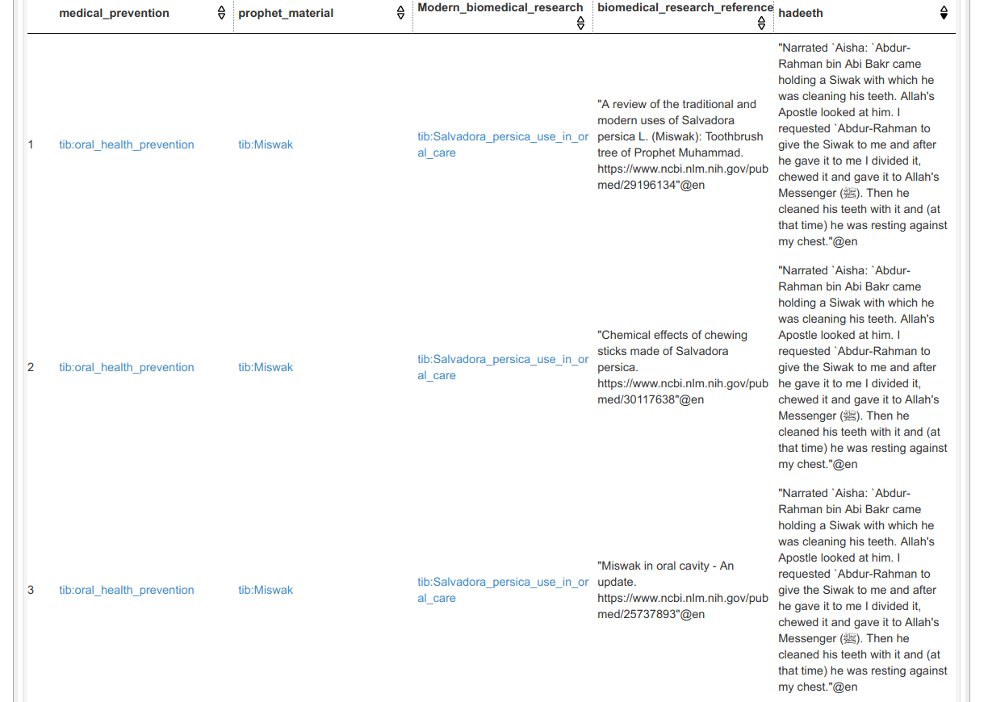

**3- The same treatment was used in both prophet time and modern n time, and it is also part of modern Chinese medicine practices:**

**Example is cupping.**

PREFIX rdfs: <[http://www.w3.org/2000/01/rdf-schema#](http://www.w3.org/2000/01/rdf-schema)>

PREFIX owl: <[http://www.w3.org/2002/07/owl#](http://www.w3.org/2002/07/owl)>

PREFIX rdf: <[http://www.w3.org/1999/02/22-rdf-syntax-ns#](http://www.w3.org/1999/02/22-rdf-syntax-ns)>

PREFIX uni: <[http://www.semanticweb.org/muna/ontologies/2018/6/TibbNabawi-ontology-15#](http://www.semanticweb.org/muna/ontologies/2018/6/TibbNabawi-ontology-15)>

SELECT distinct ?medical_condition ?annotation ?relative_papers ?Prophet_treatment ?modern_treatment ?hadeeth

WHERE {

?medical_condition rdfs:subClassOf ?x.

?x owl:onProperty uni:hasBeenTreated.

?Prophet_treatment rdfs:subClassOf uni:Prophet_timeTreatment.

?modern_treatment rdfs:subClassOf uni:ModernMedicalTreatments.

?x ?y ?Prophet_treatment .

?x ?y ?modern_treatment .

FILTER ( ?Prophet_treatment = ?modern_treatment)

optional {

?medical_condition rdfs:isDefinedBy ?annotation.

?modern_treatment rdfs:seeAlso ?relative_papers.

?modern_treatment rdfs:subClassOf ?s.

?s owl:onProperty uni:isStronglyVerifiedBy.

?ind rdf:type uni:Authentic_Hadith.

?ind uni:desrcirption_of_Hadeeth ?hadeeth.

?s ?t ?ind.

}

}

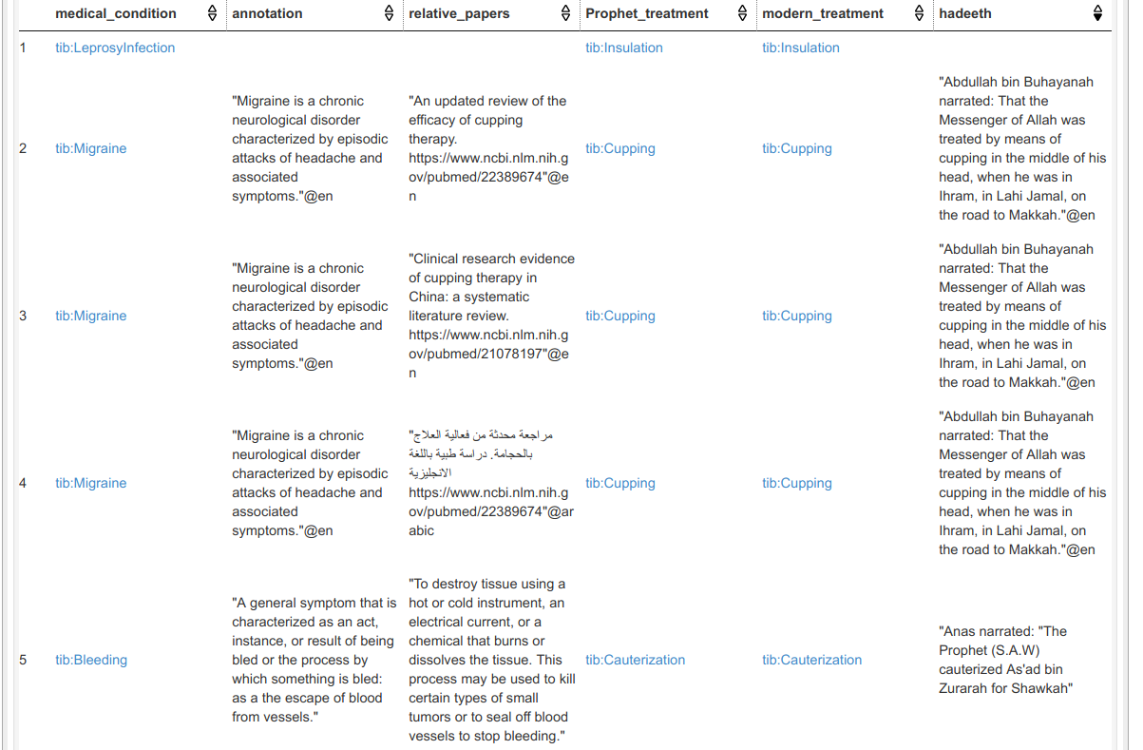

PREFIX rdfs: <[http://www.w3.org/2000/01/rdf-schema#](http://www.w3.org/2000/01/rdf-schema)>

PREFIX owl: <[http://www.w3.org/2002/07/owl#](http://www.w3.org/2002/07/owl)>

PREFIX rdf: <[http://www.w3.org/1999/02/22-rdf-syntax-ns#](http://www.w3.org/1999/02/22-rdf-syntax-ns)>

PREFIX uni: <[http://www.semanticweb.org/muna/ontologies/2018/6/TibbNabawi-ontology-15#](http://www.semanticweb.org/muna/ontologies/2018/6/TibbNabawi-ontology-15)>

SELECT distinct ?medical_condition ?annotation ?relative_papers ?Prophet_treatment ?modern_treatment ?hadeeth

WHERE {

?medical_condition rdfs:subClassOf ?x.

?x owl:onProperty uni:hasBeenTreated.

?Prophet_treatment rdfs:subClassOf uni:Prophet_timeTreatment.

?modern_treatment rdfs:subClassOf uni:ModernMedicalTreatments.

?x ?y ?Prophet_treatment .

?x ?y ?modern_treatment .

FILTER ( ?Prophet_treatment = ?modern_treatment)

FILTER (contains(str(?relative_papers) ,'China') )

optional {

?medical_condition rdfs:isDefinedBy ?annotation.

?modern_treatment rdfs:seeAlso ?relative_papers.

?modern_treatment rdfs:subClassOf ?s.

?s owl:onProperty uni:isStronglyVerifiedBy.

?ind rdf:type uni:Authentic_Hadith.

?ind uni:desrcirption_of_Hadeeth ?hadeeth.

?s ?t ?ind.

}

}

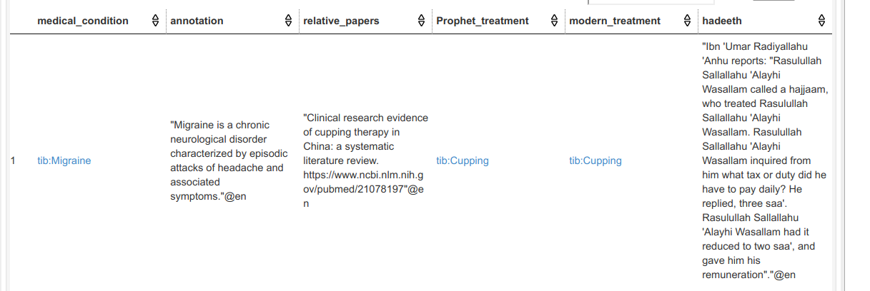

**4- The material mentioned by the prophet is currently used but in a different format**

**Example of this case is the usage of nigella or black seeds.**

**Query:**

PREFIX rdfs: <[http://www.w3.org/2000/01/rdf-schema#](http://www.w3.org/2000/01/rdf-schema)>

PREFIX owl: <[http://www.w3.org/2002/07/owl#](http://www.w3.org/2002/07/owl)>

PREFIX rdf: <[http://www.w3.org/1999/02/22-rdf-syntax-ns#](http://www.w3.org/1999/02/22-rdf-syntax-ns)>

PREFIX uni: <[http://www.semanticweb.org/muna/ontologies/2018/6/TibbNabawi-ontology-15#](http://www.semanticweb.org/muna/ontologies/2018/6/TibbNabawi-ontology-15)>

SELECT distinct ?medical_condition ?annotation ?modern_treatment relative_papers ?extracted_from_prophet_material ?hadeeth

WHERE {

?medical_condition rdfs:subClassOf ?x.

?x owl:onProperty uni:hasBeenTreated.

?modern_treatment rdfs:subClassOf ?i.

?i owl:onProperty uni:processed_from_raw_form_material.

?extracted_from_prophet_material rdfs:subClassOf uni:prophet_time_material.

?x ?y ?modern_treatment .

?i ?j ?extracted_from_prophet_material.

?medical_condition rdfs:isDefinedBy ?annotation.

optional {

?extracted_from_prophet_material rdfs:subClassOf ?s.

?s owl:onProperty uni:isStronglyVerifiedBy.

?ind rdf:type uni:Authentic_Hadith.

?ind uni:desrcirption_of_Hadeeth ?hadeeth.

?s ?t ?ind.

}

}

